Different Types of Probability distributions available

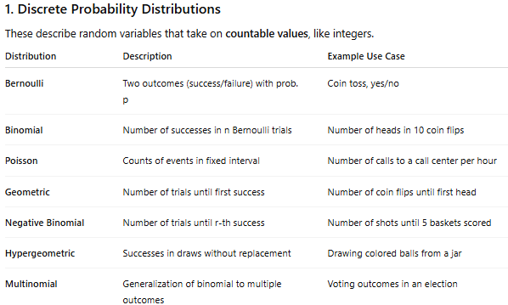
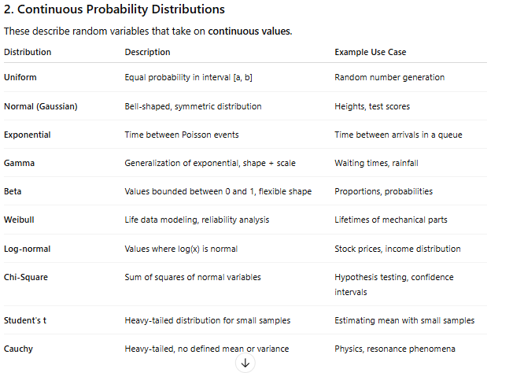

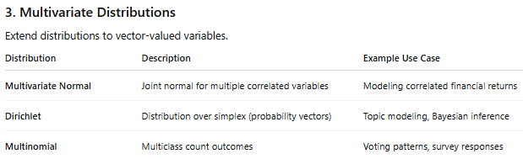

Discrete Probability Distributions

Bernoulli Distribution in Business Statistics - Mean and Variance - GeeksforGeeks
https://www.geeksforgeeks.org/data-science/bernoulli-distribution-in-business-statistics-mean-and-variance/

What is Bernoulli Distribution?
Bernoulli Distribution is defined as a fundamental tool for calculating probabilities in scenarios where only two choices are present (i.e. binary situations), such as passing or failing, winning or losing, or a straightforward yes or no. Bernoulli Distribution can be resembled through the flipping of a coin. Binary situations involve only two possibilities: success or failure. For example, when flipping a coin, it can land on either heads, representing success; or tails, indicating failure. The likelihood of achieving heads is p, and the likelihood of getting tails is 1-p or q.
Bernoulli Distribution includes a random variable with only two possible outcomes. When the variable is equal to 1, it represents success with the probability p. Whereas, when the variable is equal to 0, it shows failure. The probability of failure is q, which is calculated as 1-p.

Terminologies associated with Bernoulli Distribution
- Success and Failure: In a Bernoulli trial, the outcomes are referred to as success (1) and failure (0).
- Probability of Success (p): The probability of success occurring in a single Bernoulli trial is between 0 and 1.
- Probability of Failure (q): The probability of a failure is complementary to the probability of success and is represented as q, where q = 1 - p
- Random Variable (X): In the context of Bernoulli Distribution, X represents the variable that can take the values 1 or 0, denoting the number of successes occurring.
- Bernoulli Trial: An individual experiment or trial with only two possible outcomes.
- Bernoulli Parameter: This refers to the probability of success (p) in a Bernoulli Distribution.
- Expected Value (Mean): The average or mean outcome in a series of Bernoulli trials is often denoted as E[X].
- Variance: A measure to find how much the values of the random variable X tend to vary.
- Binomial Distribution: Bernoulli Distribution is a building block for the binomial distribution that describes the number of successes in a fixed number of Bernoulli trials.
- Geometric Distribution: Another distribution derived from Bernoulli, which models the number of trials needed to achieve the first success.
- Negative Binomial Distribution: This distribution describes the number of trials required to achieve a specified number of successes. It is also derived from Bernoulli trials.

Formula of Bernoulli Distribution
The Bernoulli Distribution formula is used to describe the probability of two possible outcomes: success and failure. It can be represented as X ~ Bernoulli (p), with parameter p that represents the probability of success. The Bernoulli distribution can be given by the Probability Distribution Function (PDF) and the Cumulative Distribution Function (CDF).
I. Probability Distribution Function for Bernoulli Distribution
PDF calculates the probability of a discrete random variable taking on a specific value. For Bernoulli Distribution, it helps in finding the probability of getting a success (1) or failure (0).
Here,
- x can only be 0 or 1.
- The PDF which is denoted as P(X = x), calculates the probability that the random variable X equals a specific value x.
- If x=1 (success), then the probability is p.
- If x=0 (failure), then the probability is q, which is the complement of p and can also be written as (1 - p).

II. Cumulative Distribution Function for Bernoulli Distribution
CDF calculates the probability of a random variable that is either less than or equal to a specific value. In Bernoulli Distribution, it tells us the probability of getting a value less than or equal to 1 or 0.
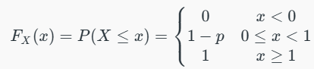
Here,
- The CDF, which is denoted as P(X ≤ x), determines the probability that X will take a value less than or equal to x.
- If x < 0, then the probability is 0.
- If x is between 0 and 1, then the probability is 1 - p.
- If x ≥ 1, the probability is 1.

Mean and Variance of Bernoulli Distribution
I. Mean (μ) of Bernoulli Distribution
The mean, also known as the expected value, represents the average outcome when we perform a large number of independent Bernoulli trials. In simple terms, if the experiment is conducted multiple times, the mean provides the expected average outcome. Specifically for a Bernoulli Distribution, mean represents the probability of success (p). For example, if the probability of success is 0.5, then the anticipated result would be 0.5.
For a Bernoulli random variable X, P(X = 1) = p (probability of success), and P(X = 0) = q = 1 - p (probability of failure). The expected value (mean) E[X] is calculated as:
E[X] = [P(X = 1) × 1] + [P(X = 0) × 0]
E[X] = (p × 1) + (q × 0)
Therefore, E[X] = μ = p
II. Variance (σ2) of Bernoulli Distribution
Variance is a measure of how spread out the possible outcomes are from the mean. For a Bernoulli Distribution, the formula for variance is p(1 - p). The variance depends on the probability of success (p) and the probability of failure (q = 1 - p). The spread, or deviation from the expected value, is determined by multiplying these two probabilities. When p is closer to 0.5, the spread will be larger. On the other hand, when p is closer to either 0 or 1, the spread will be smaller.
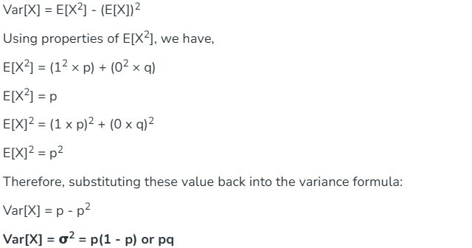
This gives the formula for the variance of a Bernoulli Distribution, which is p(1 - p) or pq.

Properties of Bernoulli Distribution
- Binary Outcomes: Bernoulli Distribution models situations with only two possible outcomes, such as success (1) and failure (0).
- Constant Probability: The probability of success (p) remains consistent across all trials in a Bernoulli Distribution.
- Independent Trials: The outcome of each trial is not influenced by subsequent trials.
- Complementary Probability: The probability of failure (q) can be found by subtracting the probability of success (p) from 1; q = 1-p.
- Discrete Probability Distribution: Bernoulli Distribution involves a finite number of different outcomes that make it a discrete distribution.
- Expected Value (Mean): The mean of a Bernoulli Distribution is equal to the probability of success (p), representing the average outcome.
- Variance: Variance (pq) measures how outcomes deviate from the mean in a Bernoulli Distribution.

Bernoulli Distribution Graph
The graph of a Bernoulli Distribution is a simple bar chart with only two bars.
1. One bar represents the outcome "1" (usually indicating success), and its height corresponds to the probability of success, "p."
2. The other bar represents the outcome "0" (usually indicating failure), and its height represents the probability of failure, "q," where q = 1 - p.
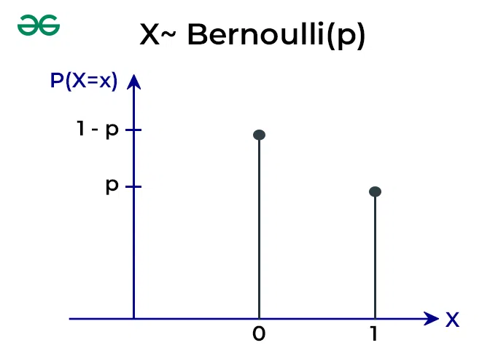
Bernoulli Trial
Bernoulli Trials are described as experiments with two possible outcomes, success and failure, yes and no, or heads and tails. In each trial, there is a probability of success (p) and a probability of failure (q). The trials are named after James Bernoulli, a Swiss mathematician who made significant contributions to the field of probability. Typical examples of Bernoulli trials include-
- Flipping a coin (heads or tails)
- Deciding if it will rain today (yes or no)
- Determining the gender of a newborn (girl or boy).
Conditions of Bernoulli Trials
- There are fixed and finite number of trials.
- Each trial is independent of another that means the result of one trial does not affect the others.
- In each trial, there are only two possible outcomes, success or failure. The probabilities of these outcomes remain consistent throughout all the trials.

Examples of Bernoulli Distribution
Example 1:
Find the probability of getting heads (success) on flipping a fair coin.
Solution:
Let X represent the outcome of the coin toss.
X = 1 if heads, X = 0 if tails.
p (probability of success) is 0.5 for a fair coin and q (probability of failure) = 1 - p is 0.5
p = 0.5.
Example 2:
If a student has a 60% chance of passing a multiple-choice test, what is the probability of them failing?
Solution:
P(X = 0) = q (Probability of Failure)
Given, p = 0.6 (Probability of Success)
q = 1 - p
q = 1 - 0.6
q = 0.4
Example 3:
If you draw a card from a standard deck, what is the probability of drawing a non-Ace card (not an Ace)?
Solution:
P(X = 0) = q (Probability of Failure)
Given, p=1/13 i.e., Probability of Success, drawing an Ace
q = 1 - p
q=1−1/13
q=12/13

Applications of Bernoulli Distribution in Business Statistics
1. Quality Control: In manufacturing, every product undergoes quality checks. Bernoulli Distribution helps assess whether a product passes (success) or fails (failure) the quality standards. By analysing the probability of success, manufacturers can evaluate the overall quality of their production process and make improvements.
2. Market Research: Bernoulli Distribution is useful in surveys and market research when dealing with yes/no questions. For instance, when surveying customer satisfaction, responses are often categorised as satisfied (success) or dissatisfied (failure). Analysing these binary outcomes using Bernoulli Distribution helps companies gauge customer sentiment.
3. Risk Assessment: In the context of risk management, the Bernoulli Distribution can be applied to model events with binary outcomes, such as a financial investment succeeding (success) or failing (failure). The probability of success serves as a key parameter for assessing the risk associated with specific investments or decisions.
4. Marketing Campaigns: Businesses use Bernoulli Distribution to measure the effectiveness of marketing campaigns. For instance, in email marketing, success might represent a recipient opening an email, while failure indicates not opening it. Analysing these binary responses helps refine marketing strategies and improve campaign success rates.
Difference between Bernoulli Distribution and Binomial Distribution
The Bernoulli Distribution and the Binomial Distribution are both used to model random experiments with binary outcomes, but they differ in how they handle multiple trials or repetitions of these experiments.

Basis | Bernoulli Distribution | Binomial Distribution
Number of Trials | Single trial | Multiple trials
Possible Outcomes | 2 outcomes (1 for success, 0 for failure) | Multiple outcomes (e.g., success or failure)
Parameter | Probability of success is p | Probability of success in each trial is p and the number of trials is n
Random Variable | X can only be 0 or 1 | X can be any non-negative integer (0, 1, 2, 3, ...)
Purpose | Describes single trial events with success/failure. | Models the number of successes in multiple trials.
Example | Coin toss (Heads/Tails), Pass/Fail, Yes/No, etc. | Counting the number of successful free throws in a series of attempts, number of defective items in a batch, etc.

Binomial Distribution in Probability
Binomial Distribution in Probability - GeeksforGeeks
https://www.geeksforgeeks.org/maths/binomial-distribution/
Binomial Distribution is a probability distribution used to model the number of successes in a fixed number of independent trials, where each trial has only two possible outcomes: success or failure. This distribution is useful for calculating the probability of a specific number of successes in scenarios like flipping coins, quality control, or survey predictions.
Binomial Distribution is based on Bernoulli trials, where each trial has an independent and identical chance of success. The probability distribution for a Bernoulli trial is called the Bernoulli Distribution.
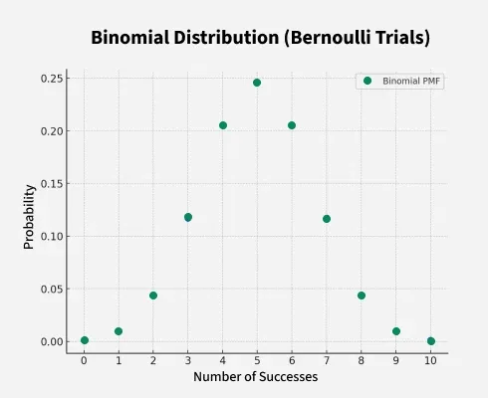

Conditions for Binomial Distribution
The Binomial distribution can be used in scenarios where the following conditions are satisfied:
- Fixed Number of Trials: There is a set number of trials or experiments (denoted by n), such as flipping a coin 10 times.
- Two Possible Outcomes: Each trial has only two possible outcomes, often labeled as "success" and "failure." For example, getting heads or tails in a coin flip.
- Independent Trials: The outcome of each trial is independent of the others, meaning the result of one trial does not affect the result of another.
- Constant Probability: The probability of success (denoted by p) remains the same for each trial. For example, if you’re flipping a fair coin, the probability of getting heads is always 0.5.

The Binomial distribution is an appropriate model to use for calculating the probabilities of obtaining a certain number of successes in the given trials.
Binomial Distribution Formula
The Binomial Distribution Formula, which is used to calculate the probability, for a random variable X = 0, 1, 2, 3,....,n is given as
Where,
- n = Total number of trials
- r = Number of successes
- p = Probability of success
Binomial Random Variable
A binomial random variable X counts the number of "successes" in n independent trials, with two outcomes in each trial: success (with probability p) or failure (with probability 1−p) and constant probability p across all trials.
Example:
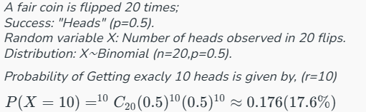

Negative Binomial Distribution
The Negative Binomial Distribution is used to model the number of trials needed to achieve a certain number of successes in a sequence of independent trials, where the probability of success in each trial is constant.
For example, consider a situation where getting 6 is the success of throwing a die. Now if we throw the die and not get 6 then it is a failure. Now we throw again and do not get 6. Let's say we don't get 6 for three successive attempts and 6 is obtained in the fourth attempt and onwards then the binomial distribution of the number of getting 6 is called the Negative Binomial Distribution.
Negative Binomial Distribution Formula
The formula for Negative Binomial Distribution is given as
Where,
- n = Total Number of Trials.
- r = Number of Trials in which we get the first success.
- p = Probability of Success in Each Trial.
- (1-p) = Probability of Failure in Each Trial.
Bernoulli Trials in Binomial Distribution
Bernoulli Trial are a sequence of independent experiments, where each experiment (or trial) results in exactly two possible outcomes:
- Success (with probability p)
- Failure (with probability 1−p)
A random experiment is called Bernoulli Trial if it satisfies the following conditions:
- Trials are finite in number
- Trials are independent of each other
- Each trial has only two possible outcomes
- The probability of success and failure in each trial is the same.
The binomial distribution models the number of successes in a fixed number of Bernoulli trials.

Binomial Distribution Calculation
Binomial Distribution in statistics is used to compute the probability of likelihood of an event using the above formula. To calculate the probability using binomial distribution we need to follow the following steps:
- Step 1: Find the number of trials and assign it as 'n'.
- Step 2: Find the probability of success in each trial and assign it as 'p'
- Step 3: Find the probability of failure and assign it as q where q = 1-p
- Step 4: Find the random variable X = r for which we have to calculate the binomial distribution
- Step 5: Calculate the probability of Binomial Distribution for X = r using the Binomial Distribution Formula.
The use of the above steps has been illustrated using an example below:
Binomial Distribution Examples
- Finding the probability of getting exactly 6 heads when a fair coin is flipped 10 times.
- Finding the probability of exactly 3 bulbs being defective when a batch of 100 bulbs is tested and each bulb has a 2% chance of being defective.
- To find the Probability of exactly 7 patients responding positively to the treatment when the drug is tested on 8 patients and has a 90% success rate.
Let's say we toss a coin twice, and getting head is a success we have to calculate the probability of success and failure then, in this case, we will calculate the probability distribution as follows:
In each trial getting a head that is a success, its probability is given as:
- p = 1/2
- n = 2 as we throw a coin twice
- r = 0 for no success, r = 1 for getting head once and r = 2 for getting head twice

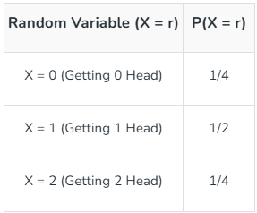
Binomial Distribution Visualization
Binomial Distribution Graph is plotted for X and P(X). We will plot a Binomial Distribution Graph for tossing a coin twice where getting the head is a success. If we toss a coin twice, the possible outcomes are {HH, HT, TH, TT}.
The Binomial Distribution Table for this is given below:
X (Random Variable) | P(X)
X = 0 (Getting no head) {TT} | P(X = 0) = 1/4 = 0.25
X = 1 (Getting 1 head) {HT, TH} | P(X = 1) = 2/4 = 1/2 = 0.5
X = 2 (Getting two heads) {HH} | P(X = 2) = 1/4 = 0.25
Binomial Distribution Graph for the above table is given below:

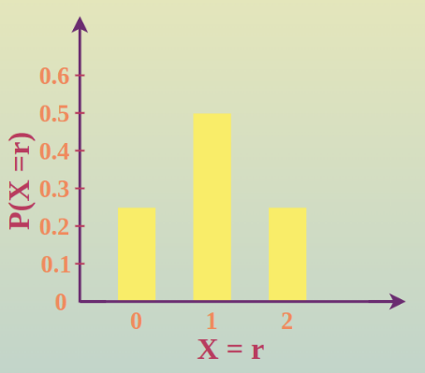

Beta Distribution:
The beta distribution is a continuous probability distribution defined on the interval [0, 1]. It’s commonly used to model probabilities, proportions, and random variables that must stay between 0 and 1.
📌 Key Characteristics
1. Defined by two shape parameters
The beta distribution has two positive parameters:
- α (often written as a)
- β (often written as b)
These control the shape of the distribution.
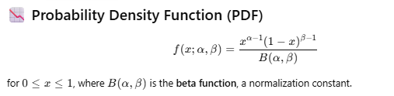
🎨 How shape parameters affect the distribution
- α = β = 1 → uniform distribution on [0, 1]
- α > 1 and β > 1 → bell-shaped (peaks in the middle)
- α < 1 and β < 1 → U-shaped
- α > 1, β < 1 → skewed right
- α < 1, β > 1 → skewed left
🧠 Intuition
You can think of the beta distribution as representing a belief about the probability of success in a Bernoulli process.
Example:
If you observed:
- 8 successes
- 2 failures
A typical Bayesian prior/posterior estimate of the probability p would be:
p∼Beta(9,3)

📘 Common Uses
✔ Bayesian statistics (especially for probability of success)
✔ Modeling proportions (click-through rates, conversion rates)
✔ Random variables bounded between 0 and 1
✔ Prior and posterior distributions in Bernoulli/Binomial models

